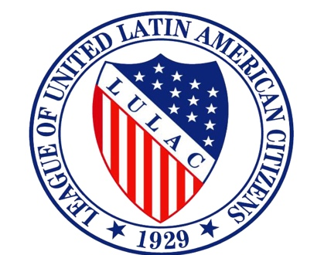
LULAC Youth Board
Phone Conference Minutes
08/02/16 @ 1:03pm CST
- Prayer read by: Pedro Mondragon

- Pledge by: Mark Anthony Sandavol

Meeting Called to Order @ 1:03pm CST
- National Youth President: Jared Hernandez
- National VP for the Youth: Michael Urteaga
- National Youth Secretary: Angelica Juarez
- National Youth Treasurer: Mark Anthony Sandavol
- National Youth VP for Young Woman
- National Youth VP for the Southwest: Luis Adame
- National Youth VP for Southeast: Pierce Wilson
- National Youth VP for the Midwest: Vivica Lewis
- National Youth VP for Northwest: Maria Hernandez
- National Youth VP for Northeast: Jenesis Duran
- National Youth Parliamentarian: Pedro Mondragon

Southwest
- Members not active, difficulty making sure they are active.
- solution: increase engagement by creating more committees and creating small projects.
- Council was not nationally involved…running positions.
- Increase membership.
-solution: making sure existing councils re-charter.
Michael Urteaga: Do more bonding as a council besides volunteer and community work.
Jared: personally talk to each non active member and get their feedback on what the don’t like.

Northeast:
- Immigration laws, Police brutality
- Reach out to high school councils
- Create a calendar for list of events
- Creating some sort of healthy competition game…youth Olympics
Jared: Lulac Press Release, visit police stations, create blog on lulacyouth.net, inform others about issues.
VP for the Youth
Interactive educational Workshops, robotics, aviator, trades kills. Make convention free.
Board Approves Scholarship Idea*
Jessica Toledo motions to adjourn Meeting end at CST 2:08PM CST
Mark Anthony Sandoval seconds to adjourn meeting.
FYI: Washington Youth Leadership Seminar : September 21,2016-Sep. 24th, 2016
Duration of Call: 1hr 12 minutes
-Minutes by Angelica Juarez

