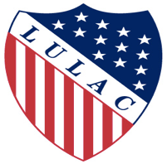

LULAC Youth Board
Meeting
7/15/16 1:00pm

Meeting Called to Order @ 2:58 pm EST
  - Prayer read by Rosa Delgado
  - Pledge by Genesis Duran
  - Roll Call of Officers by Jared Hernandez (National Youth President)
[Damien Absent]

Closing Remarks

Meeting adjourned at 1:33pm EST
Minutes by Angelica Juarez

