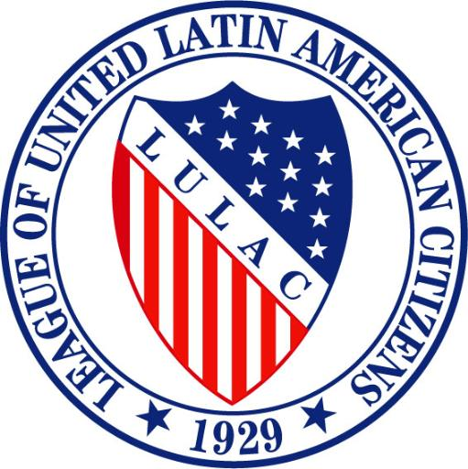

National LULAC Youth Board Meeting
Friday, April 15th, 2016
San Diego, CA
Prayer – by President Hernandez

Pledge – by Treasurer Sandavol

Meeting Called to Order 8:37am

Roll Call of Officers
National Youth President- Jared Hernandez
National VP for Youth- Anna Valenzuela-Estrada
National VP of Southwest- Rosa Delgado: excused
National VP of Northeast- Damian Bess
National VP of Midwest- Bethany Oceguera: excused
National VP for Young Woman- Elida Martinez: excused
National Youth Treasurer- Mark-Anthony Sandoval
National Youth Executive Director- Jenesis Duran: excused
National Youth Directory of Publicity- Jessica Toledo
National Youth Secretary- Angelica Juarez

Presidential Report- Jared Hernandez
Attended District 3 Youth Convention, also attended the Women's Conference. Started a council at Fossil Ridge High (First General Meeting April 19th, 2016)
(Florida State Convention May 28-29th)- 2 new youth councils created in Florida.
(TX State Convention June 9-12th)- will be attending.
(Northwest Regional Youth Conference June 24th-25th)- lodging & meals sponsored.
Electronic Voting- active this year, cannot run from the floor must submit names by Wednesday during the first general assembly.
Sine elections in July- there have been12 new chartered councils, 235 new members. 24% increase in membership not including 2 councils in the making.

Damien motions to accept.
Mark Anthony seconds.

VP for Youth Report- Ana Valenzuela-Estrada
2016 will be last year as VP for Youth, commends each member of the board for everything each and all have achieved. Board has come a long way, and it is visible. Excited for out future and will gladly continue to stay in touch with each member.
Damien Bess motions
Mark Anthony seconds.

Youth Regional VP's Reports
National VP of Northeast Damien Bess: unsure if will be running for position but is in search for a member who will uphold the position. Is working on councils around areas and staying in contact with Dr. Butler, receives no replies from Dr. Garcia but will continue to contact.

Treasures Report
Mark Anthony Sandoval: Received Money from membership dues and new charters for travel. Went over budget from SeaWorld.

Old Business
- Women’s Conference/National Board Meeting

New Business

- National Convention Rules:
Appointments for Sergeant of Arms: Sandra Council #298
Roger Velasquez #1929
Damien Bess motions to accept national convention rules.
Mark Anthony Sandavol second’s the motion.
- Northwest Regional Youth Conference (June 24-25th)
- Pre-Convention/Convention (10-12th, 13th-16th)
- Youth Pins- ordering pins for the youth. $5 for youth. $10 for adults.
Damien Bess motions to order 1,000 and to sell them.
Mark Anthony Sandavol second’s.
- PepsiCo Grant= $58,000
$10,000 youth board of 4 states.
$18,000 to 10 youth councils.
Council #1929
Council #1021
Council #1118
Damien Motions to accept 3 councils
Mark Anthony seconds.

Sunday 6pm next phone conference.
April 22nd resubmit day.

Committee Reports
Break into Committee’s

Good & Welfare

Adjournment @ 11:00AM.
Damien Bess motions to adjourn
Mark Anthony seconds.

